Multipliers Quantifiers

✖️ What Are Multipliers Quantifiers?
# Source: AI Source: Provided by: [Data Path: Persons Table -> ID Column: 1, Name_En Column: Motasem Essam] -> From: [ChatGPT] on [7/28/2025]
Multiplier quantifiers indicate how many times something is multiplied, increased, or repeated.
They express comparison in terms of quantity or degree — usually with countable or uncountable nouns.

✅ Common Multiplier Quantifiers:
# Source: AI Source: Provided by: [Data Path: Persons Table -> ID Column: 1, Name_En Column: Motasem Essam] -> From: [ChatGPT] on [7/28/2025]
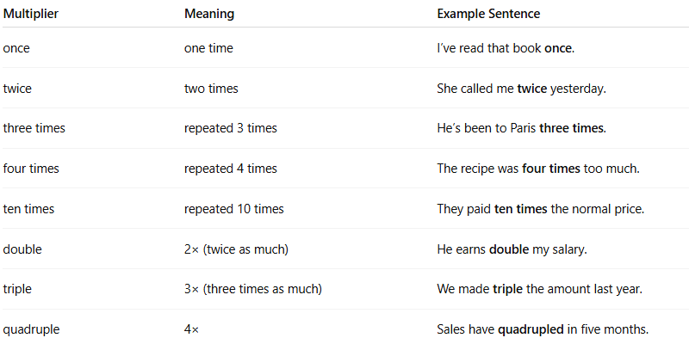
Multiplier | Meaning | Example Sentence
once | one time | I’ve read that book once.
twice | two times | She called me twice yesterday.
three times | repeated 3 times | He’s been to Paris three times.
four times | repeated 4 times | The recipe was four times too much.
ten times | repeated 10 times | They paid ten times the normal price.
double | 2× (twice as much) | He earns double my salary.
triple | 3× (three times as much) | We made triple the amount last year.
quadruple | 4× | Sales have quadrupled in five months.

🧠 Structures with Multipliers:
# Source: AI Source: Provided by: [Data Path: Persons Table -> ID Column: 1, Name_En Column: Motasem Essam] -> From: [ChatGPT] on [7/28/2025]
- [Multiplier] + noun
  - Double money, triple effort
- [Multiplier] + as + adjective + as
  - This road is twice as long as that one.
  - She is three times as fast as her opponent.

💬 Notes:
# Source: AI Source: Provided by: [Data Path: Persons Table -> ID Column: 1, Name_En Column: Motasem Essam] -> From: [ChatGPT] on [7/28/2025]
- Multipliers can act like quantifiers, adverbs, or determiners depending on context.
- Used often in comparisons, measurements, and mathematics.

